and some config (but with enabled showScriptName option) in config/test. php:

'components' => [

// ...

'urlManager' => [

'enablePrettyUrl' => true,

'showScriptName' => true,

'rules' => [

['class' => 'yii\rest\UrlRule', 'controller' => 'api/posts'],

],

],

],

1. Add the web/.htaccess file with the following content:

RewriteEngine On

RewriteCond %{REQUEST_FILENAME} !-f RewriteCond %{REQUEST_FILENAME} !-d RewriteRule . index.php

1. Check that the api/posts controller works:

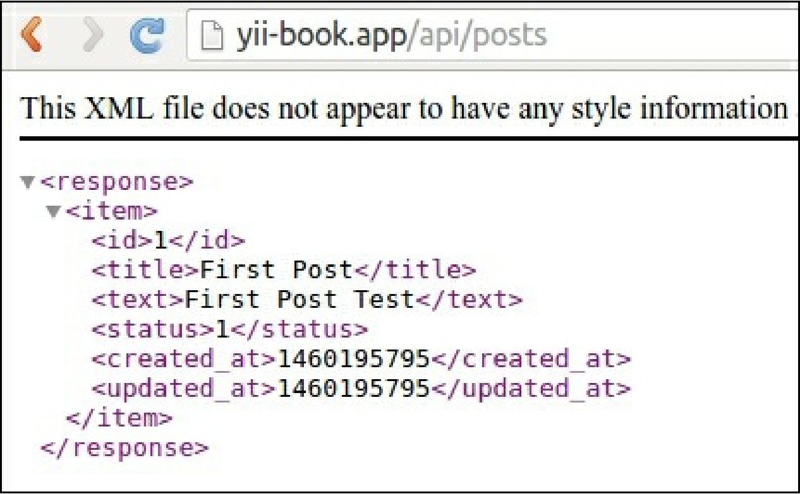

1. Create the API test suite tests/api. suite. yml configuration file with the REST module:

class_name: ApiTester modules: enabled:

* REST:

depends: PhpBrowser

url: '<http://127.0.0.1:8080/index-test.php'>

part: [json]

* Yii2:

part: [orm, fixtures] entryScript: index-test.php

Now rebuild testers: composer exec codecept build